
Amazon Interview Worksheet
HIRE AND DEVELOP THE BEST
Definition and Indicators
Hire and Develop the Best: Leaders raise the performance bar with every hire and promotion. They recognize exceptional talent, and willingly move them throughout the organization. Leaders develop leaders and take seriously their role in coaching others. We work on behalf of our people to invent mechanisms for development like Career Choice.
What this looks like in Practice
As a people manager do you… | As an individual contributor do you…
- Take the interviewing process seriously by understanding the job and focusing on hiring people who we can learn from and who will raise the high performance bar?
- Identify the right job description and candidate profile to attract the best candidates and to raise the performance bar?  - Do whatever it takes by being relentless and creative to hire the best candidates?  - Make it a priority to coach and teach employees; provide regular feedback?  - Recognize and act upon poor performance and hiring mistakes quickly?  - Help employees drive their own development and learning by regularly discussing career goals, strengths and areas for development; identifying development activities and moves for all employees? | - Drive your own development and learning by actively discussing career goals, strengths and areas for development and pursuing activities that support your growth?  - Invest in the growth of others by taking ownership to mentor and guide them when you have expertise in a particular area?

Hire and Develop the Best - Suggested Behavioral Interview Questions
For each question you choose, use a separate STAR Worksheet
Questions for (Manager) in parentheses

- Give me an example of one of the best hires of your career. How did this person progress through their career? What did you identify during the hiring process that drove his or her success?
- Tell me how you help your team members develop their careers. Can you give me two to three examples of specific people in whom invested and how you helped them develop their careers including one who wasn’t being successful but you saw potential and chose to invest?
- Give me an example of a time you have provided feedback to develop and leverage the strengths of someone on your team. Were you able to positively impact that person’s performance? What were your most effective methods?
- Tell me about your hiring process when you hire key positions such as direct reports. Where do you go for talent? What resources do you employ? What are the steps in the process? What traits do you seek that will tell you the candidate will be successful on the team apart from the obvious hard skills? [probe how they assess specific things in an interview such as integrity? Do they do reference checks? How do they use them?} (Manager)
- Tell me about someone that you hired that you thought was better than you in a number of areas. How did you add value to that person? (Manager)
- Tell me about a time when you had a low performing individual on your team. How did you deliver feedback to this person? Did their performance improve or did they leave the organization? (Manager)
- Give me an example of someone who was promoted one or two levels up in the organization – not just because they were a star who would naturally rise, but due to your development/coaching efforts. (Manager)
STAR WORKSHEET
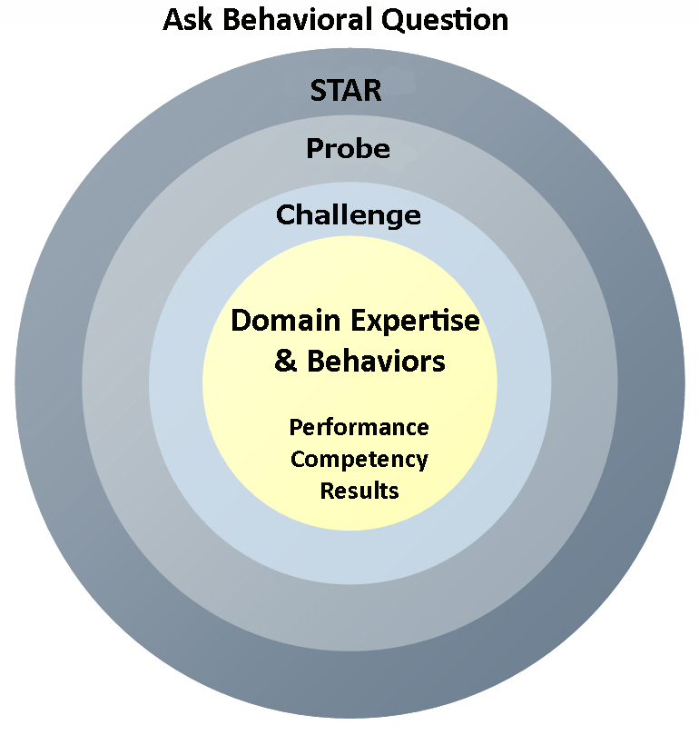
Your Behavioral Question:___________________________________________________________________Leadership Principle:_________________

- Choose behavioral question that provoke specific examples or stories for your assigned Leadership Principle(s).
- Process the example using STAR. Stories have beginnings (Situation/Task), middles (Actions) and ends (Results).
- Once you have established the story, PROBE to dive deeper on your assigned competency (Leadership Principle), get clarity or pursue a concern.
- If appropriate, CHALLENGE the candidate’s statements, decisions or thought process.
S  T | SITUATION/TASK - Describe the situation/task you faced and the context of the story  Answers the questions: where did this occur, when did it happen, why is it important?  Probing Questions:  - Why is this important? What was the goal?  - What was the initial scope of the project? What were the challenges?  - What were the risks and potential consequences if nothing happened?  Challenge Questions:  - Why did you choose this story to illustrate a xyz accomplishment?  - What other stories can you think of that demonstrate.. xyz?  - Could you come up with an example that is more recent? | Notes
A | ACTION - What actions did you take?  Answers the questions: what did you personally own, how did you do it, who else was involved?  Probing Questions:  - Deep probe functional expertise and/or assigned core competency.  - Were you the key driver or project owner?  - What was your biggest contribution? What unique value did you bring?  - What were the most significant obstacles you faced? How did you overcome them?  Challenge Questions:  - What did you do specifically versus the team?  - How did you set priorities…deal with xyz problem… or get manager buy-in?  - What decisions did you challenge? Why? How did you influence the right outcome?
R | RESULTS - How did you measure success for this project? What results did you achieve?  $ Cost savings, revenue generation  # Quantify to understand volume, size, scale  % Percentage change, year over year improvements  Time to market, implementation time, time savings  Impact on the customer, the team  δ Quality improvements  Probing Questions:  - Why did you choose to focus on these results? What other results were important?  - You mentioned revenue, what percentage change is that year over year?  - What trade-offs did you have to make to achieve this? (quality, cost, time)  - I’m concerned about… (the time it took, the volume, the customer impact), tell me more…  Challenge Questions:  - What were the lessons learned? What would you have done differently?  - How would you implement this at Amazon?  - How did these results compare to your actual goals? (refer back to goal stated in Situation)

